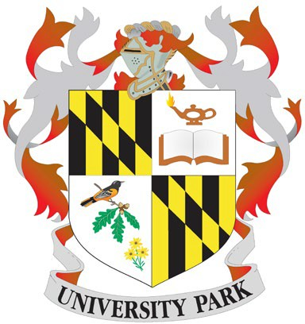
MEETING OF
UNIVERSITY PARK MAYOR AND COMMON COUNCIL
WILL BE HELD
VIA VIDEO AND AUDIO CONFERENCE
7:45 p.m.
January 22, 2026
REGULAR SESSION

The meeting will take place at Town Hall in the conference room. This meeting will be conducted as a hybrid meeting. Members of the public may only join the meeting virtually.
To join the meeting through Zoom, please use the link below.

Join Meeting: https://us02web.zoom.us/j/89189649729?pwd=NVRweGplSStIdm5UYStTY0g4TFUydz09
To join with audio only, dial: (301) 715-8592
Meeting ID: 891 8964 9729
Passcode: 441152

Public Participation:
Participants who join the video/audio conference will be muted during the meeting except for Mayor, Council, and staff. Participants can turn their video on during the meeting, so we can all see each other, or can turn it off if they would rather. Participants will have the opportunity to speak during Public Comment - agenda item #4. During that time, all participants will be taken off mute. If you would like to comment, please state your name and Mayor Morrissey will call on you to speak. Public comments will be limited to three minutes.
Public comments or questions may also be made by emailing the Town Clerk TC Hegeman at thegeman@upmd.org. All electronic comments must be submitted by 12 p.m. on January 22, 2026. Written comments have been provided to the Mayor and Council and are part of the record.

- CALL TO ORDER: Mayor Morrissey

Present: Dubayah | Absent: | Dubayah
Gathercole |  | Gathercole
Kelby |  | Kelby
Mowery |  | Mowery
McGaughey |  | McGaughey
Godfrey |  | Godfrey
Sweet |  | Sweet

APPROVAL OF THE AGENDA

MOTION TO ENTER INTO CLOSED SESSION TO DISCUSS A PERSONNEL MATTER GENERAL PROVISIONS ARTICLE §3-305 (B) (1) AND TO RECEIVE ADVICE FROM THE TOWN ATTORNEY ON A LEGAL MATTER GENERAL PROVISIONS ARTICLE §3-305 (B) (7)

RETURN TO OPEN SESSION

ADJOURNMENT

**A Closed Session will be called**

